Solve the maze and help these little piggies find their way to the beach!

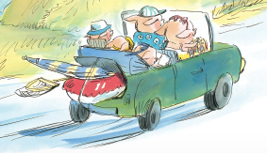
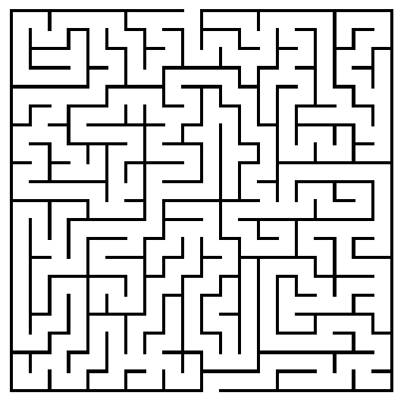
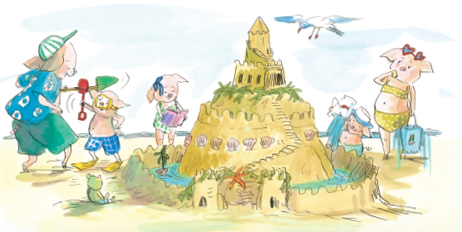

Inspired by These Little Piggies Go to the Beach by Amy E. Sklansky,
illustrated by Christine Davenier Moondance Press/Quarto ©2018

