Join this little piggy at the beach and draw your own sandcastle below!

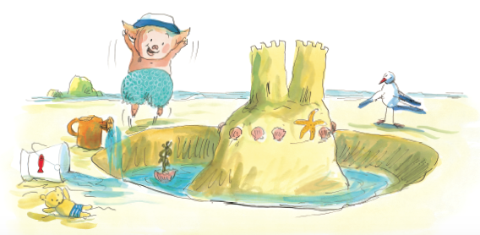

My sandcastle:

Inspired by These Little Piggies Go to the Beach by Amy E. Sklansky,
illustrated by Christine Davenier Moondance Press/Quarto ©2018

